## **MAVENS MARKETING REPORT**

This is a report on analysis done for mavens marketing. It originally contains data of over 2000 customers and was analyzed using SQL and powerBi.

# DATA CLEANING

First, I cleaned the data by checking for duplicates, errors and nulls. To check for duplicate I started of using COUNT then COUNT DISTINCT. I was able to deduce that we had 2240 distinct rows of data.

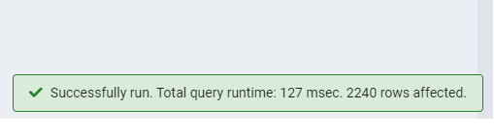

Then I moved on to check on nulls across each column and found 24 null values in income.

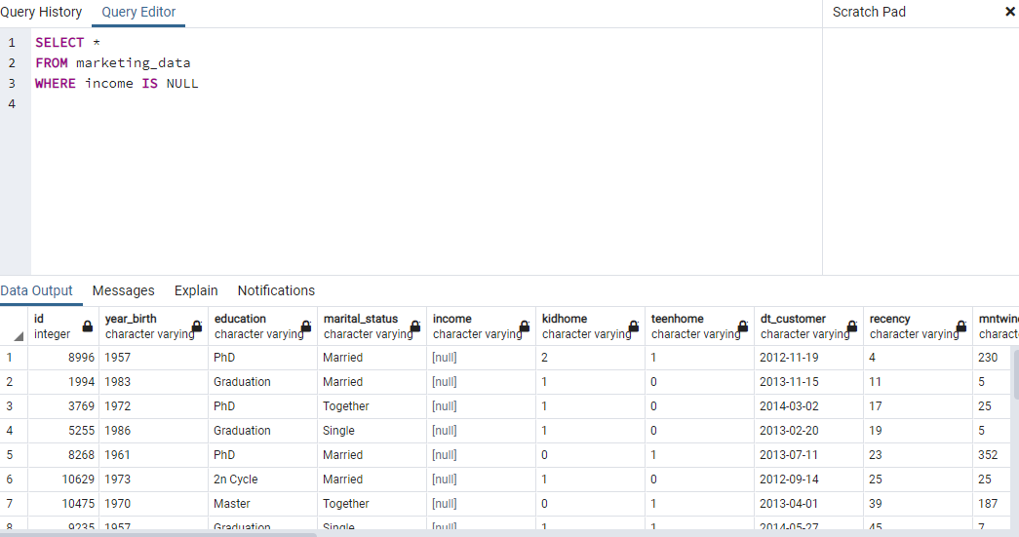

Then I replaced the null values with 0 using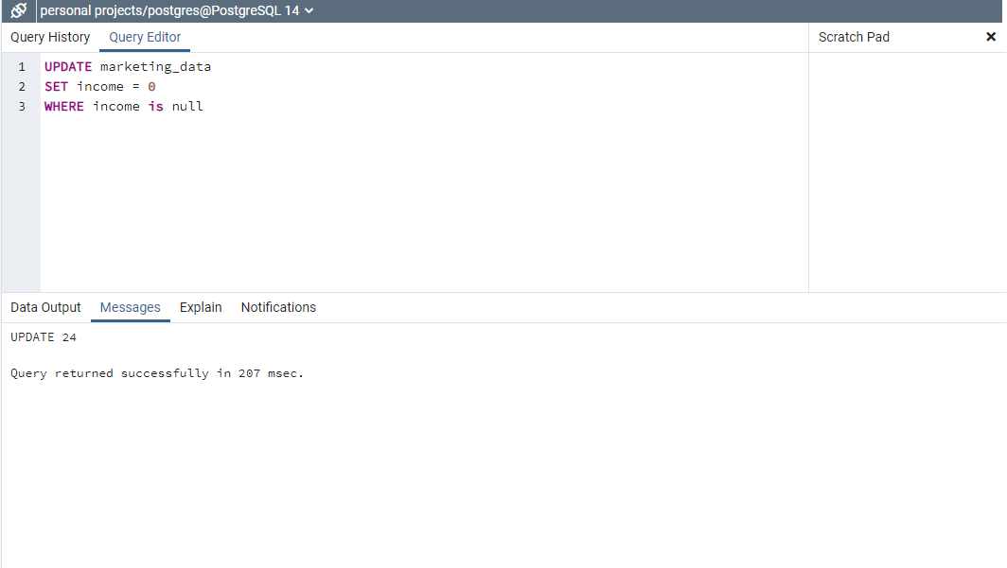

The data was uploaded on power QUERY and year of birth was converted age and then DAX was used to create age range. On further cleaning all 24 rows with zero income so that other values in other columns don’t skew the result.

# **DATA ANALYSIS**

We have a total of 2216 customers with 1M in sales and only 21 complaints in the last 2years. From our analysis, STORE PURCHASES is the most preferred method of shopping by the customers followed closely by WEB PURCHASES. Most web purchases are done by married customers between the ages of 41-50years. Least performing channel of purchase is the DEALS PURCHASE. Spain has the highest number of purchases via WEB channel and USA has the least.

Amongst products sold, FRUITS is the least purchased and Meat products are the most purchased products.

On campaign strategy, the 1st campaign was the most successful and 2nd campaign was least successful amongst customers.

The above report gives us insight into who our average customers are. The average customer is 52 years old and earns 52k yearly, but they have only used $607 to purchase products in the last 2years and have visited our web channel at least 5 times.

# Recommendation

* Our data shows that the largest market is in Spain with 85% and most of them are either married or living together. Further marketing campaign should begin then move further into countries with lesser customer presence
* From the report DEALS are the most underutilized channel for purchasing products and FRUITS are the least purchased products ,therefore campaigns similar to the 1st campaign which was widely accepted should be used to improve purchase of this product and use of DEALS..
* Also judging from the income yearly and the average spent on products, the disparity is a lot and can be improved by using the most accepted campaign and direct it towards the demographic between the ages of 50-60.
* The disparity between average amount spent on products and yearly income should be further analyzed to lessen the gap and increase revenue.